**Project Document**

* SQL Script was placed inside project folder “Starwars/starwars.sql”
* Below Screenshots for project view was placed.
* Listing by Datatable with filters and paginate

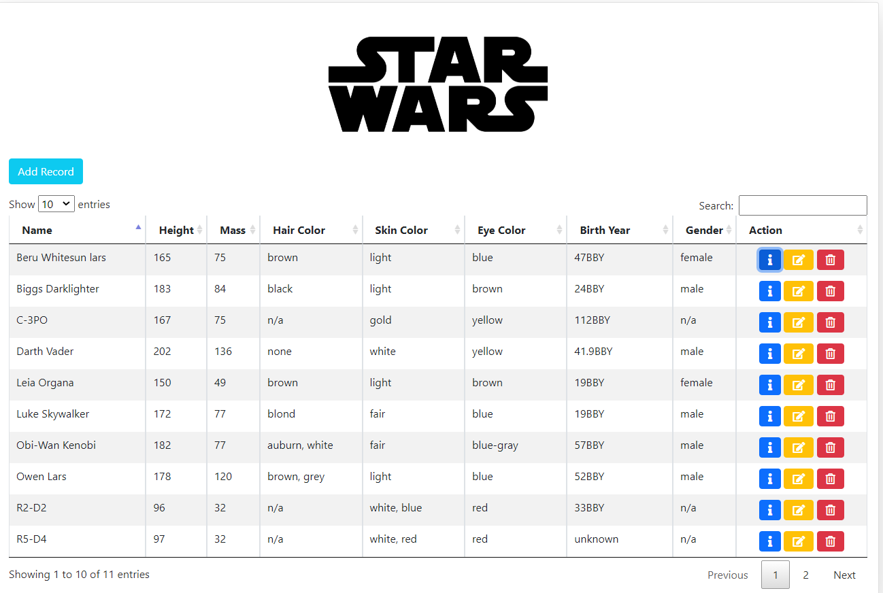

* Update Record using model.

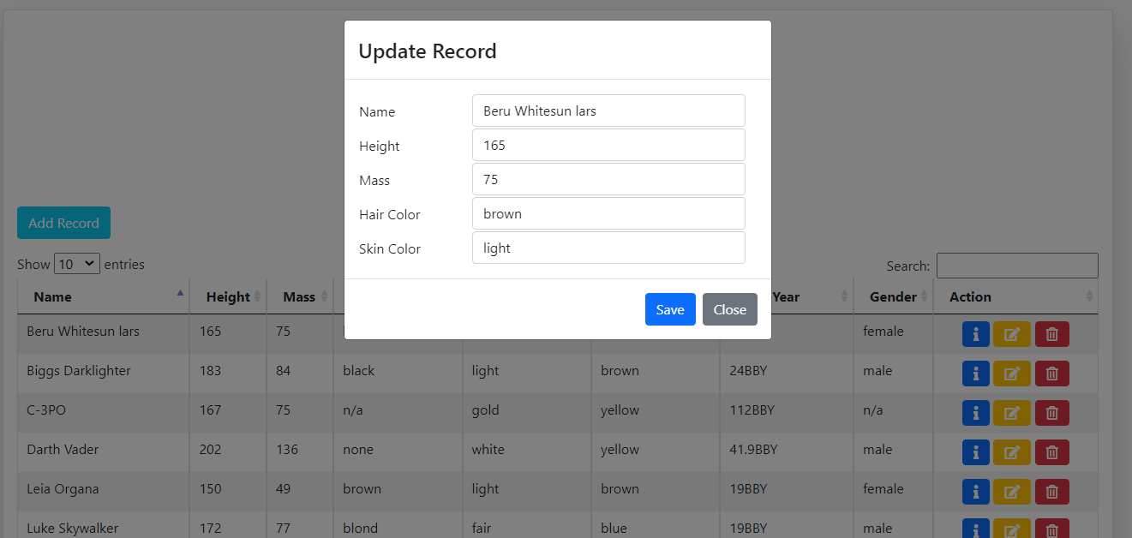

* Add Records

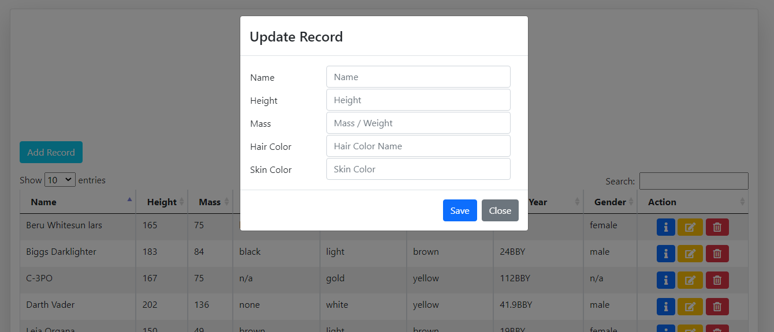

* Delete Record

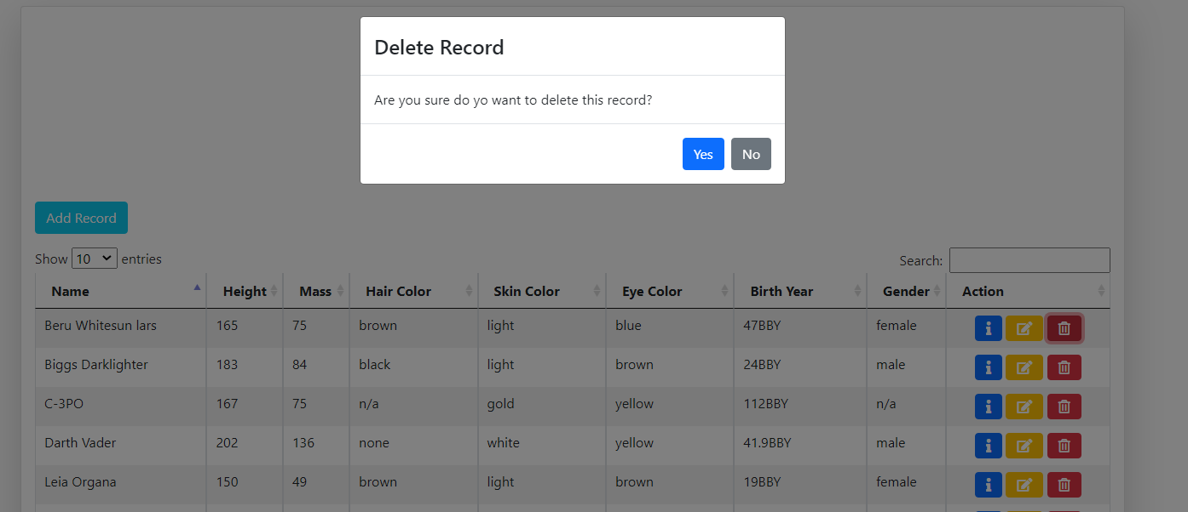

* Character Info

